**TITLE:SMART PARKING SYSTEM**

INTRODUCTION:

Smart parking is a technical advancement that makes use of sensors and information technology to assist users in finding available parking spaces. It is a management approach for parking lots in many facilities for users to find satisfactory parking places

**DESIGN AND INNOVATION:**

**Market Research and Needs Assessment:**

Begin by understanding the specific needs and challenges of your target market. Consider factors such as parking demand, urban density, types of vehicles, and user preferences.

**System Architecture:**

Design the system's architecture, including hardware, software, and network infrastructure. Consider the following components:

**Sensors**: Use various sensors like ultrasonic, infrared, or cameras to detect the availability of parking spots.

Communication Infrastructure: Implement a robust communication network to connect sensors, users, and the central control system.

**Central Control System:** This will process data from sensors, manage the database, and control access to parking spots.

**User-Friendly Mobile App:**

Develop a mobile application for users to easily find and reserve parking spots. The app should provide real-time information about parking availability, location, pricing, and navigation to the spot. Consider features like cashless payments, notifications, and user reviews.

**COMPONENTS NEEDED:**

* **ARDUINO UNO**
* **IR SENSOR**
* **SERVO MOTOR**
* **20x4LCD DISPLAY**
* **I2C MODULE**
* **CONNECTING WIRES**
* **USB CABLE(for uploading code)**

**ARDUINO SETUP:**

The Arduino Uno is used to create a smart car parking system. The device uses IR sensors mounted in the parking slots to detect empty slots and assists the driver in finding parking in a new city. The system lacks a payment mechanism as well as guide technology that can automatically find available parking spaces.

**BLOCK DIAGRAM:**

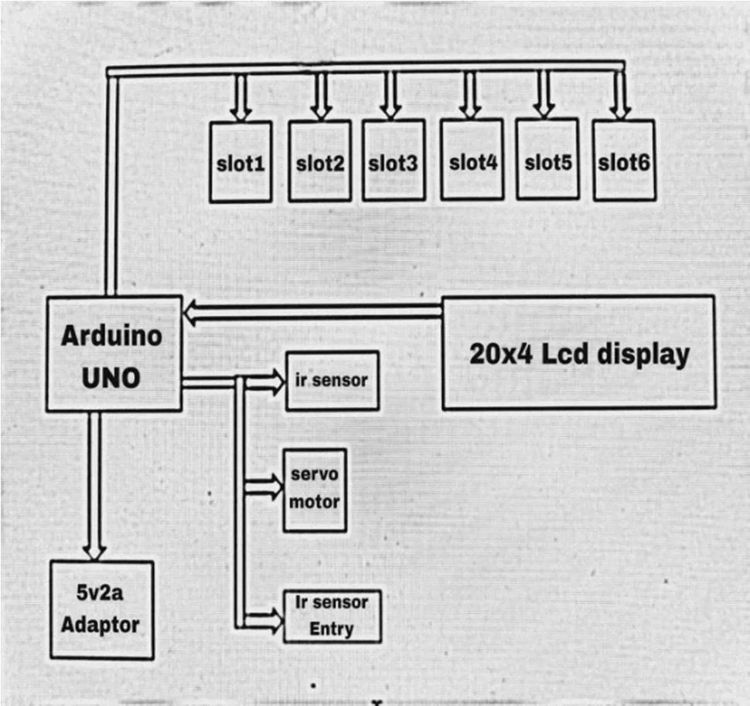

**USES:**

**ARDUINO UNO:**

The Arduino Uno is used to create a smart car parking system. The device uses IR sensors mounted in the parking slots to detect empty slots and assists the driver in finding parking in a new city.

**IR SENSOR:**

When a car arrives, the IR sensors sends signal to Arduino and it decodes the signal and then the servo motor opens the gate for the car to pass. The second IR sensor is used to indicate the cars which are going outside and the value of the spots is incremented by Arduino.

**SERVO MOTOR:**

The servo motors, LCD display, and IR sensor are all connected to an Arduino Uno microcontroller unit. The LCD shows how much space is available, and the IR sensors keep track of how many automobiles enter and exit the parking place. The IR sensors identify whether or not a parking place is available.

**LCD 20 x 4:**

In Slot, the sensor is used to detect cars. Arduino is connected to these infrared sensors. The Arduino provides a command to the IR sensor whenever a car is parked in a building, and the IR sensor then sends the command to the LCD, which has 20*4 size.

**I2C MODULE:**

Connect the GND pin of the Arduino with the GND pin of the I2C module, the brown wire of the servo motor, and the GND pin of both the IR sensors. Attach the orange(signal) wire of the servo motor to the digital-9 pin of the Arduino.

**BENEFITS OF SMART PARKING SYSTEM:**

* **Optimized parking.**
* **Reduced traffic.**
* **Reduced pollution.**
* **Enhanced User Experience.**
* **Integrated Payments and POS.**
* **Increased Safety.**
* **Real-Time Data and Trend Insight.**
* **Decreased Management Costs**

**CONCLUSION:**

As soon as parking place is found to be empty it is detected using ultrasonic sensors which report it further. We achieved this by programming the sensors and Arduino. Pushing the data to webpage gives us tabular output which shows availability of parking places.